2

Some useful information:

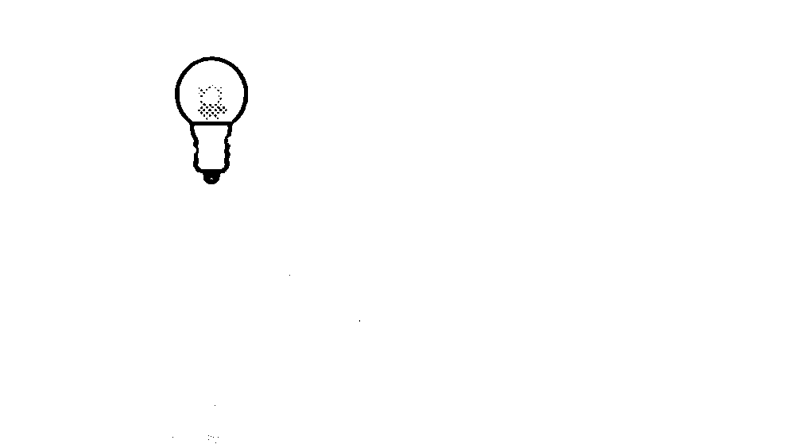  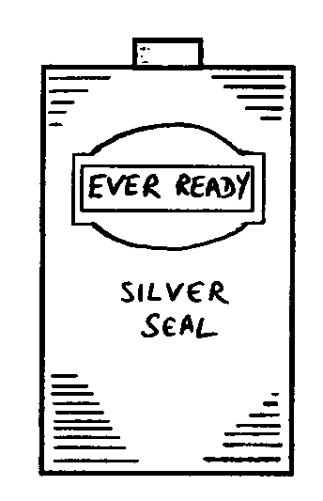  The two contact points on a torch battery are at the ends: |  | The two contact points on a torch bulb are the tip and the screw thread:

Look at each of the circuits below. Tick one box () to show if the bulb is lit or not.

a. b.

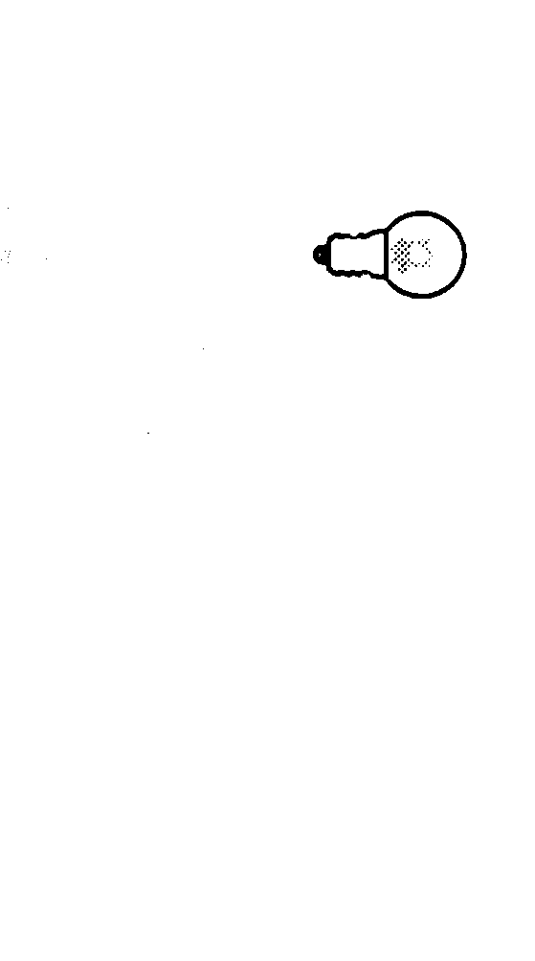

.

not lit
lit
.

not lit
lit

c. d.

.

not lit
lit

.

not lit
lit

